**Trainer Notes:**

**Note: Once the student completes the ONTAPADM labs please inform support to reset the PODs to DATAPROT images, since in our environment we use two different images for ONTAPADM and DATAPROT classes.**

Do not continue with DATAPROT class on same ONTAPADM image which may results in storage outage. This will lead to shut down of the images in all the PODs, which will need to reset the PODs to initial state to access the images back.

**Module 0: Welcome**

**Exercise 1: Checking the Exercise Equipment**

**Note:** In our lab environment we use AD and Jumphost as a same server and the IP is set to **192.168.0.253**. So, use **DNS, NTP and Gateway** as **192.168.0.253** throughout the lab.

**Task 3: Verify that Required License Codes Are Installed**

**Page9_Step3-1:** The license **VE** is not installed in our lab environment due to region restrictionand the **iSCSI** license will be installed in both the clusters.The screenshot may vary with the license installed so kindly refer the below image.

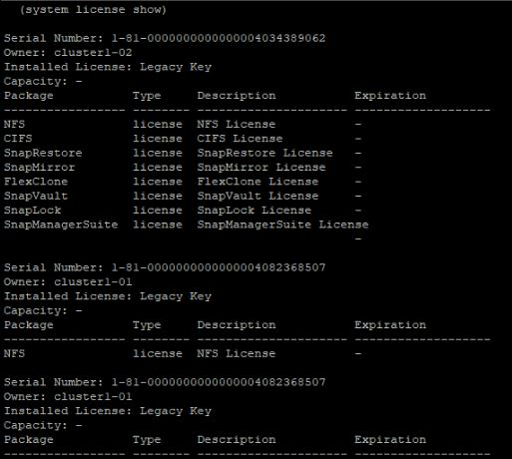

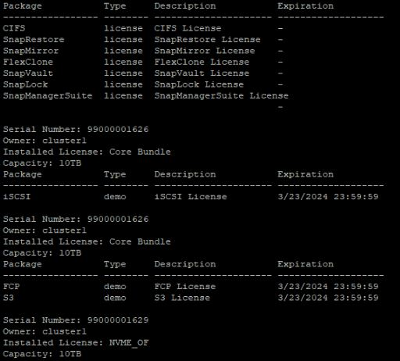

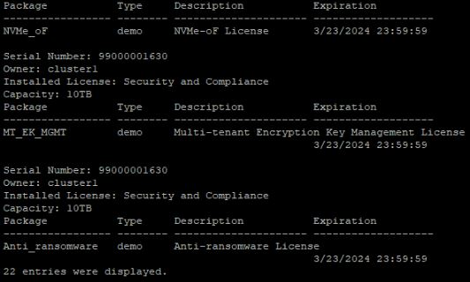

**Module 3: Cluster Management**

**Exercise 1: Managing ONTAP Clusters and Administrators**

**Task 1: Create a Login Banner and MOTD.**

**Page2_Step1_8:** In the **MOTD**, the first node in the cluster will be displayed in the node section.

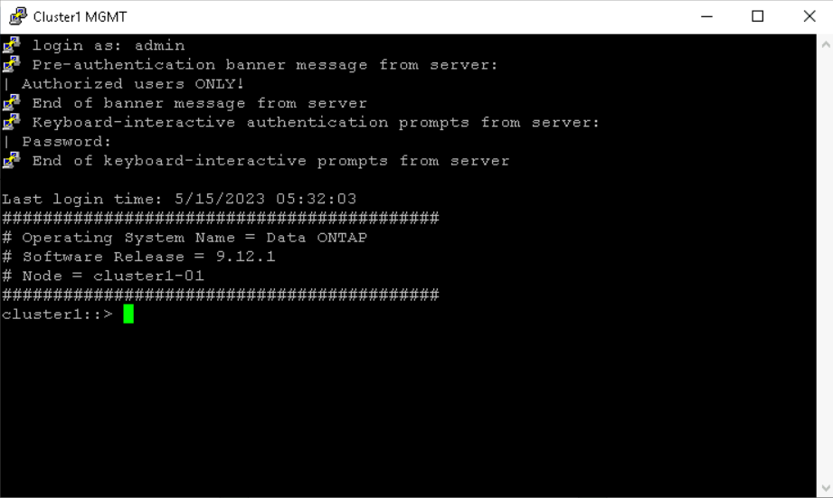

**Module 4: Network Management**

**Exercise 2: Managing Virtual Network Resources**

**Task 2: Create Subnets for Automatic IP Address Assignment**

**Page10_Step2-6:** Click **OK** to confirm subnet association.

**Module 7: Data Access**

**Exercise 3: Configure iSCSI in a Storage VM**

**Task 3: Configure the iSCSI Software Initiator on the Windows Host**

**Page16_Step 3-17:** The screenshot given in the guide varies, so kindly refer the below image.

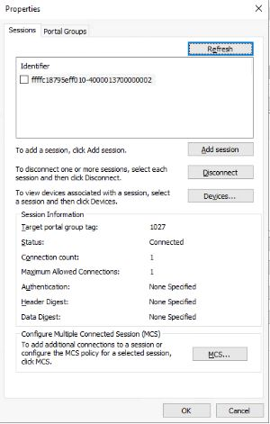

**Task 4: Access the iSCSI-Attached LUN from the Windows Host**

**Page17_step4-3, Step5-6:** **Initialize the disks after bringing both the disks online in step 5-6.** Right click **Disk 1** then select **Initialize Disk.** In the **initialize disk** dialogbox**, select both the disks and click ok.**

**Page186_Step4-16 & 4-17**: If you didn’t get the dialog box to format the disk, then skip these steps and continue with **step 4-18.**

**Exercise 4: Configuring NVMe in a Storage VM**

**Task 4: Access the NVMe-Attached Namespace from the Linux Host**

**Page10_Step4-5:** The sample output in the guide varies. Please refer the below image.

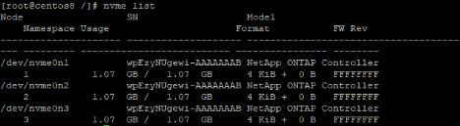

**Page11_Step4-6, Step4-7, Step4-8**: Use the following commands to build the filesystem in the respective **NVMe namespaces.**

* **mkfs –t ext2 /dev/nvme0n1**
* **mkfs –t ext3 /dev/nvme0n2**
* **mkfs –t ext4 /dev/nvme0n3**

**Page12_Step4-10:** Use the following commands to attach the three **NVMe namespaces** to the three **mount point directories**.

* **mount /dev/nvme0n1 /nvme_vol1_ext2**
* **mount /dev/nvme0n2 /nvme_vol2_ext3**
* **mount /dev/nvme0n3 /nvme_vol3_ext4**

**Page12_Step4-11:** The sample output in the guide varies. Please refer the below image.

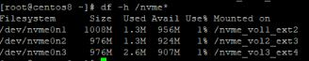

**Exercise 5: Configuring the S3 Protocol in a Storage VM**

**Note: Before creating the S3 server, check the date and time skew between Jumphost and cluster1. If the time and date behind or ahead between them, then fix the difference and continue to create the S3 server.**

**Task 1: Enable the S3 Protocol in a Storage VM**

**Page7_Step1-19:** Save the certificate in the **Downloads** folder location.

**Task 6: Configure S3 Protocol Access to a NAS Share**

**Page26_Step6-27:** In the **Add Bucket** page, click **More Options** and then specify the following settings:

* Name: **svm4-nas2-bucket1**
* Storage VM: **c2_svm4**

**Task 7:** **Access to the S3 Object Store using the AWS CLI(optional)**

**Page34_Step7-3**: Enter the **Cluster1 S3 user account** details.

**Page34_Step7-4:** If the upload fails due to time out, then check the time and date between Cluster and Jumphost. The time differs more than 5 minutes, fix the clock skew and try uploading again.

**Module 8: Data Protection**

**Exercise 2: Encrypting a Volume**

**Note:** This lab is meant for theory alone; lab practice is not possible as the **NVE** license is not provided for training purpose.

**Module 10: Cluster Maintenance**

**Exercise 1: Installing and Configuring Active IQ Config Advisor.**

**Task 1: Download and Install Config Advisor**

**Page1-5_Step1-1 to 1-15**: Skip **Task 1** as the **Active IQ Config Advisor Tool** is already downloaded and installed on the Windows Jumphost.

**Task 2**: **Use Config Advisor to Verify Cluster Health**

**Page6_Step2-1:** Connect to the Config Advisor Server using[**https://localhost:8445**](https://localhost:8445).

**Page7_Step2-5 to 2-6:** Proceed with the next step if the pop-ups doesn’t appear.